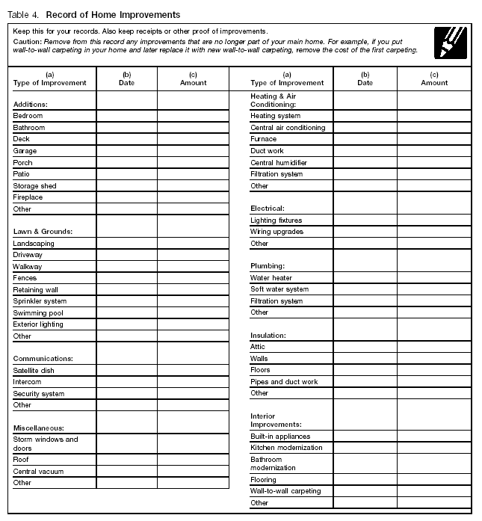
Sondra C. Safer

Certified Public Accountant

16800 W. Greenfield Ave.

Brookfield, WI 53005-6803

262-784-6710 Fax: 262-784-6787
Sondra@safercpa.com www.safercpa.com

